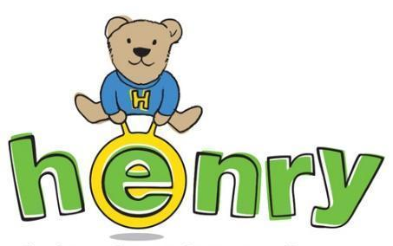
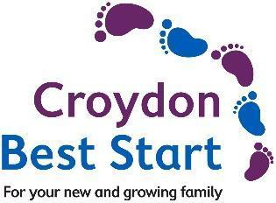

Thank you for your referral to the HENRY programme

Eligible groups
- Families with children 0-7yrs, who live in Croydon (or registered with a Croydon GP)
AND
- Families with children whose weight is above the 91st weight centile OR
- Families from areas with higher rates of obesity at reception and year 6 (see map in Appendix A) OR
- Ethnic groups with higher rates of obesity - Black African or Black Caribbean (see graph in Appendix B) OR
- Other high-risk groups e.g. children with a physical or learning disability OR
- Families whom the evidence base suggests would benefit from additional healthy behaviours support
Parent/s or carer/s details
First name/s
Surname/s
Address and postcode
Email
Preferred contact telephone number
First language | Choose an item.
Interpreter required including sign language? | Yes/No
Youngest child’s details (0-7yrs)
First name
Surname
Date of birth

Reason for referral (Tick all that are relevant)
Please tick: |  | Child’s weight over the 91st centile. Please provide centile, or height and weight if available
 |  | Child’s weight is increasing over time but not yet over the 91st centile.
 |  | Parental overweight or obesity or overweight or obesity in older siblings (only if in eligible area/group)
 |  | From at risk ethnic groups* (see Appendix B) | Black African
 |  |  | Black Caribbean
 |  | Child with LTC, SEND or physical disabilities
 |  | Family have requested support for parenting, food, activity, diet (only if in eligible area/group)
 |  | Managing food behaviours at meal times (only if in eligible area/group)
 |  | Support with cooking on a budget (only if in eligible area/group)
By checking this box, you are confirming that the client is aware of and agrees with this referral and understands that their information is being shared with HENRY for the purpose of processing the referral.
Please tick box to show that you have understood.◽
Referrer’s details
Name
Role

Please send this form to croydon@henry.org.uk, via secure platform or password protected email.

The parent will be contacted within 3 working days.

Information for practitioners:
- HENRY is a national children's charity that focuses on supporting families to lead healthier lives.
- We are an evidence based service that encompasses a whole host of different topics relating to healthy family lifestyle and getting children off to the best start - including.. healthy eating, family activity, emotional and mental health, parental confidence and parenting skills, oral health and much more.
- The HENRY approach works by supporting families in a “partnership” approach, whereby we:
  - …start where families are
  - …help families identify what is going well
  - …build parental confidence
  - …support families to make small, manageable steps toward their preferred future
- HENRY has been commissioned by Croydon Council as the provider for the Early Years Healthy Behaviours service (Tier 1 and Tier 2) until 2026.
- Tier 1 relates to workforce training for local practitioners
  - Practitioners who work directly with families with children 0-7yrs are eligible.
  - We are targeting practitioners that work with “high-risk” parents
  - If you are interested in joining an upcoming training, email croydon@henry.org.uk

Tier 2 relates to direct delivery of group programmes for families
- HENRY programmes run over 8 consecutive weeks, covering a variety of topics.
- We deliver programmes face-to-face in local community venues, as well as having an option to join online.
- Families receive a toolkit full of resources.
- Programmes begin January 2023.
- Please signpost families to our website www.henry.org.uk / our Facebook www.facebook.com/HENRYinCroydon / to contact us directly on 0208 156 6400 for more details

Thank you for your support.

Appendix A: Rates of obesity across Croydon
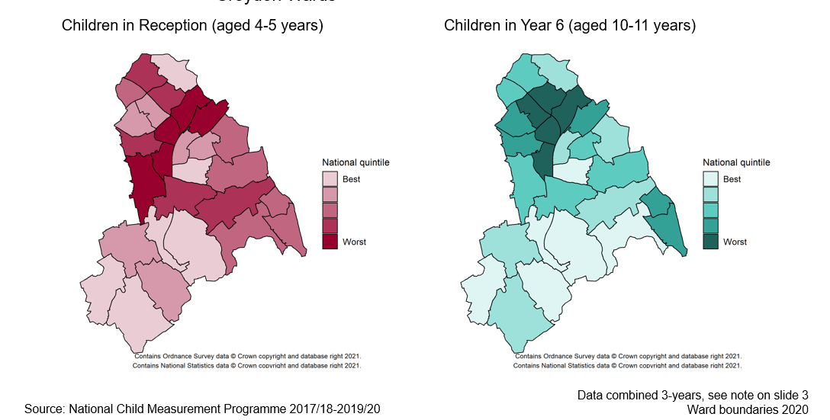

Appendix B: Rates of obesity by broad ethnic grouping
